**Social Worker Role Profile**

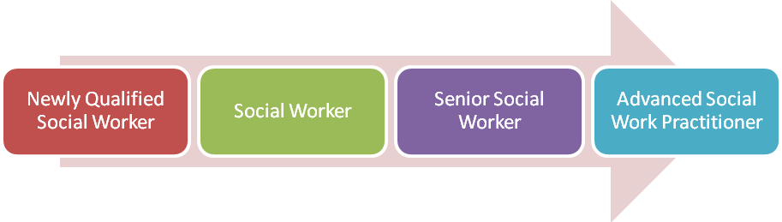

The *Social Worker Role Profile* describes the typical activities, required skills and knowledge together with the desired behaviours of a Social Worker at each of the four non-management levels of the *Social Worker Career Path*.

**DIRECTORATE:** Adult Social Care

**GRADE:** Newly Qualified Social Worker SO1

Social Worker POA

Senior Social Worker POB

Advanced Social Work Practitioner POC

**EVALUATED:** November 2014

**SALARY & ADDITIONAL ALLOWANCES**

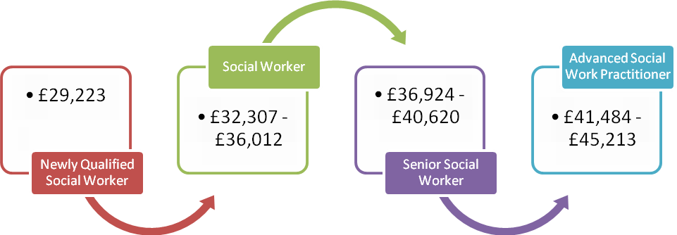

£31,557

£34,884 -£38,883

£39,867 - £43,860

£44,790- £48,819

**Practice Educators (PE)**

Social Workers who are relevantly qualified and active Practice Educators receive an additional PE allowance of £1,800 p.a.

**Professional Registration & DBS**

It is a requirement for continued employment that professional registration as a Social Work is maintained with the HCPC.

An Enhanced DBS Check is a requirement of all Social Worker roles.

**CAREER PROGRESSION**

A *Newly Qualified Social Worker* (NQSW) will be appointed at SO1 grade at salary point 25. NQSW's will participate in the Assessed & Supported Year in Employment programme (ASYE). Completion of the ASYE is a condition for successfully completing the employment probation period for all NQSW's.

Upon successful completion of the ASYE / probation period then the NQSW will automatically progress to a Social Worker role at grade POA. The Social Worker will then be able to progress by annual increments dependent on satisfactory performance in line with professional standards.

Once a *Social Worker* has a minimum of 2 years post-qualifying experience they may request a 'fast-track' assessment of their practice. Successful demonstration of professional standards against the 'Experienced' level of the Professional Capabilities Framework (issued by the College of Social Work) will allow progression to the *Senior Social Worker* role, appointed at the base salary of grade POB.

Appointment to the *Advanced Social Work Practitioner* role is by recruitment selection when suitable vacancies are available.

**PURPOSE**

To provide a high-performing social work service to adults in the community in accordance with departmental policies and procedures and statutory requirements.

The post-holder may work in one of the following service areas;

▪     Hospital and Localities (Older People & Physical Disabilities)

▪     Learning Disability and Autism

▪     Mental Health

▪     Adult Safeguarding

**TYPICAL ACTIVITIES**

**Newly Qualified Social Worker (NQSW)**

* Maintain professional registration and compliance with council's DBS requirements.
* Participate in and complete the Assessed Year in Employment (ASYE) programme.
* To manage, within a supervised framework, a limited client caseload, including safeguarding adults.
* Accept referrals from Supervisor or Team Manager.
* Interview clients and other relevant people. This may take place in a work setting, at the client's home or other related venue such as schools or hospitals.
* Assess nature of issues, identify relevant objectives to resolve problems and to take effective action to achieve solutions.
* Employ a variety of social work models and techniques in addressing the client's requirements.
* Appropriately apply available resources in order to meet the needs of the client.
* Maintain confidentiality and compliance with all data protection protocols.
* Receive regular professional supervision while maintaining a critical reflective approach to practice.
* Recognise own professional limits and seek appropriate advice from Supervisor, Team Manager or other experienced Social Workers where required.
* Work collaboratively with other council officers and other agencies such as the police, health workers, voluntary sector organisations and partners.
* Demonstrate awareness and compliance with required Standards including the Social Work Professional Capabilities Framework (ASYE level).

**Social Workers**

* Manage a wider, increasingly complex social work caseload including safeguarding adults, with more autonomy.
* Demonstrate expertise in one or more areas of social work practice.
* Use range of frameworks for assessment and intervention.
* Provide support for trainees and other employees, including acting as a 'buddy' for inductees.
* Take responsibility for obtaining regular, effective supervision from appropriate Social Worker to ensure effective practice, critical reflection and career development.
* Demonstrate comprehensive understanding and use of knowledge related to area of practice, including critical awareness of current issues and new evidence-based practice research.
* Recognise discriminatory practices and appropriately challenge service users, colleagues and senior staff.
* Be responsible for proactive measures in response to emergency safety and liberty issues.
* Demonstrate cost-consciousness in the application of available resources.
* Maintain knowledge of current team plan and of own contribution in delivering this.
* Demonstrate awareness and compliance with required Standards including the Social Work Professional Capabilities Framework (Social Work level).
* Use a wide range of evidence sources to inform decision-making.
* Clearly report and record judgements, decisions and analysis using the appropriate system (Protocol / AIS).
* Act as Deprivation of Liberty (DOLS) Best Interest Assessor (following appropriate training and with minimum of 1 year post-ASYE practice experience).

**Senior Social Workers**

*In addition to the typical activities of a Social Worker a Senior Social Worker will;*

* Manage social work caseload of more complex nature and with high levels of autonomy.
* Provide expert professional and technical advice to other Social Workers, managers, colleagues and partners.
* Provide professional supervision of other Social Workers (circa 3-6), supporting caseload management and promoting reflective practice and continuous professional development.
* Demonstrate skilled use of range of frameworks for assessment and intervention.
* Model and help others develop social work professionalism and effective caseload management.
* Establish network of internal and external colleagues to support effective practice.
* Prepare reports for Court of Protection.
* Participate in Panel processes.
* Chair professional meetings with inter-agency partners and clients.
* To produce management information and analysis.
* Participate in team planning and contribute to the delivery of team and service plans.
* Demonstrate awareness and compliance with required Standards including the Social Work Professional Capabilities Framework (Experienced Social Worker level).

**Advanced Social Worker Practitioners**

*In addition to the typical activities of a Senior Social Worker an Advanced SW Practitioner will;*

* Provide professional leadership to social work colleagues through demonstrating exemplary practice, sharing knowledge and positively managing the interface between practice and education / training.
* Act as organisational expert in role specialism, providing advice and support to other social work colleagues and partners.
* Manage social work caseload of most complex cases.
* Model and take responsibility for workforce planning and workload allocation systems to sustain the Standards for Employers of Social Workers.
* Provide professional practice supervision, coaching & mentoring to other Social Workers, ensuring practice is informed by research and encouraging critical reflective practice and continuous professional development (circa 6-10 across multiple teams).
* Provide professional consultation to all teams within the directorate and other agencies, ensuring effective and efficient practice and procedures are in place.
* Provide direct observations of social work practitioners.
* Develop and maintain professional networks across a range of partner organisations and sectors.
* Demonstrate awareness and compliance with required Standards including the Social Work Professional Capabilities Framework (Advanced level).

**PROFESSIONAL STANDARDS**

The Professional Capabilities Framework (PCF) published by *The College of Social Work* outlines the professional standards required by each level of Social Worker in the London Borough of Hillingdon (LBH). These standards are outlined across nine 'domains' - Contexts & Organisations; Critical Reflection & Analysis; Diversity; Interventions & Skills; Knowledge; Professional Leadership; Professionalism; Rights, Justice & Economic Wellbeing and Values & Ethics.

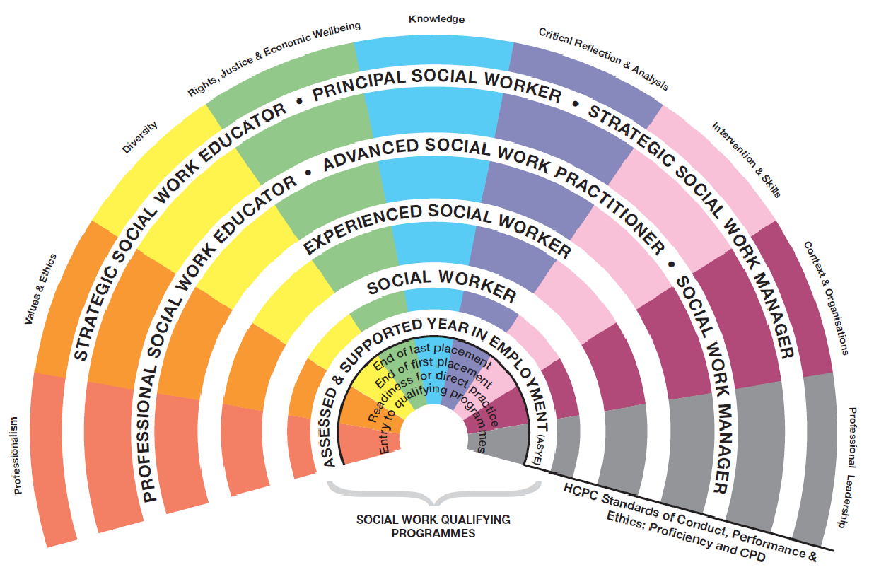

The *Social Worker Role Profile* maps directly onto the PCF as indicated below. Social Workers should familiarise themselves with the appropriate standards set out in the PCF as they form the basis of the professional performance standards for Social Work roles in LBH.

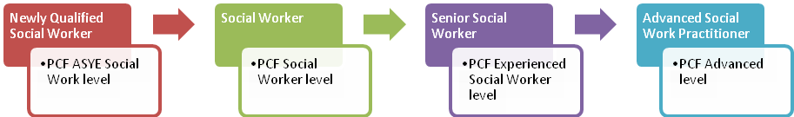

**STANDARDS FOR EMPLOYERS OF SOCIAL WORKERS**

The London Borough of Hillingdon is committed to implementing *The Standards for Employers of Social Workers in England*.

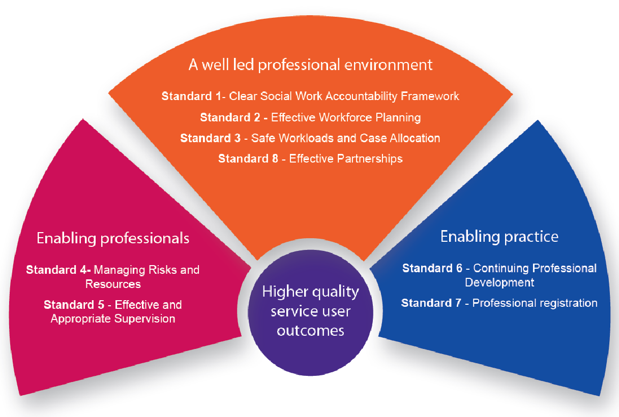

These Standards, published by the Local Government Association on behalf of the Social Work Reform partners, aim to sustain high quality outcomes for service users.

The Standards provide for clear accountability, effective resourcing and allocation of workloads to ensure risks are safely managed. They ensure that each Social Worker received regular, high-quality supervision together with access to appropriate training and continuing professional development.

**PERSON SPECIFICATION**

*This Person Specification is used during recruitment selection and progression assessment.*

|  |  |  |  |  |
| --- | --- | --- | --- | --- |
|  | **Newly Qualified Social Worker** | **Social Worker** | **Senior Social Worker** | **Advanced Social Work Practitioner** |
| **Professional Standards** | PCF ASYE standards essential | PCF Social Worker standards essential | PCF Experienced Social Worker standards essential | PCF Advanced standards essential |
| **Professional Social Work Degree or equivalent** | Essential | Essential | Essential | Essential |
| **Postgraduate qualification in relevant SW discipline** | Not required | Desirable | Desirable | Essential |
| **Practice Educator Professional Standards (PEPS)** | Not Required | Desirable | Stage 1 & 2 essential  (this training can be offered as part of external appointment where opportunities have not existed in other organisations - appointment is conditional on successful completion of training) | Stage 1 & 2 essential  (this training can be offered as part of external appointment where opportunities have not existed in other organisations - appointment is conditional on successful completion of training) |
| **Indicative postgraduate Experience** | 0 years | 12 months (ASYE) | 3 years+ | 6 years+ |
| **Current UK Driving License or Equivalent** | Desirable | Desirable | Desirable | Desirable |
| **Access to own vehicle insured for work purposes** | Desirable | Desirable | Desirable | Desirable |
| **Experience in the assessment and care management of older people and/or people with disabilities.** | Essential | Essential | Essential | Essential |
| **Experience in the application of the Mental Capacity Act 2005 and the Care Act 2014.** | Essential | Essential | Essential | Essential |
| **Clear verbal and written communication skills** | Essential | Essential | Essential | Essential |